**Project Design Phase-II**

**Technology tableau (Architecture & Tableau)**

|  |  |
| --- | --- |
| Date | 26 June 2025 |
| Team ID | LTVIP2025TMID48508 |
| Project Name | Heritage Treasures: An In-Depth Analysis of UNESCO World Heritage Sites in Tableau |
| Maximum Marks | 4 Marks |

**Technical Architecture:**

The Deliverable shall include the architectural diagram as below and the information as per the table1 & table 2

Guidelines:

Include all the processes (As an application logic / Technology Block)

Provide infrastructural demarcation (Local / Cloud)

Indicate external interfaces Indicate Data Storage components / services

Indicate interface to machine learning models (if applicable)

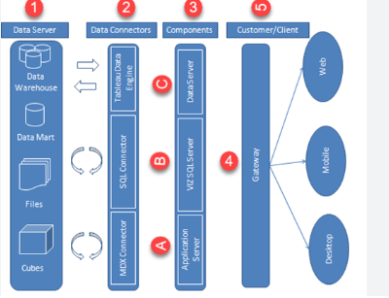

**Table-1 : Components & Technologies:**

|  |  |  |  |
| --- | --- | --- | --- |
| **S.No** | **Component** | **Description** | **Technology** |
|  | User Interface | Tableau Dashboard interface for users | Tableau Dashboard interface for users |
|  | Application Logic-1 | Data cleaning, deduplication, formatting | Python (Pandas), Excel |
|  | Application Logic-2 | Enhances data with metadata from UNESCO/Geo APIs | Text analysis to categorize tags |
|  | Application Logic-3 | Text analysis to categorize tags | Python NLP (NLTK or spaCy) |
|  | Database | Storage of heritage site data | . Excel / CSV / MySQL |
|  | Cloud Database | Cloud-based storage (if hosted) | Google Sheets / IBM Cloudant |
|  | File Storage | Stores dataset files and images | IBM Cloud Object Storage / Google Drive |
|  | External API-1 | Fetches UNESCO site metadata | . UNESCO World Heritage API |
|  | External API-2 | Gets map data for visualization | Google Maps API |
|  | Machine Learning Model | NLP model for tag classification (optional) | . spaCy / Scikit-learn |
|  | Infrastructure (Server / Cloud) | Data processing + visualization deployment | . Tableau Desktop / Tableau Cloud |

**Table-2**: Application Characteristics:

| **S.No** | **Characteristics** | **Description** | **Technology** |
| --- | --- | --- | --- |
|  | Open-Source Frameworks | Data processing and visualization aided by open-source libraries | Python (Pandas, spaCy), Jupyter, Tableau |
|  | Security Implementations | Access-controlled publishing if on Tableau Cloud | OAuth, Password Protection (Tableau), HTTPS |
|  | Scalable Architecture | Modular architecture for data processing and analytics | ETL pipelines + Tableau Layer |
|  | Availability | Hosted on Tableau Public or Cloud – accessible globally | Tableau Cloud / Public |
|  | Performance | Pre-processed data, aggregated views, optimized dashboard filters | Data Extracts in Tableau, Filters, LOD Expr |